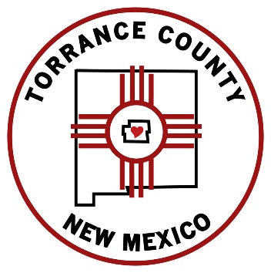 | Torrance County  BOARD OF COUNTY COMMISSIONERS (BCC)  Ryan Schwebach, Chair, District 2  LeRoy M. Candelaria, Vice Chair, District 3  Kevin McCall, Member, District 1

Janice Y. Barela, County Manager

SPECIAL ADMINISTRATIVE
MEETING AGENDA

THURSDAY, NOVEMBER 17, 2019 @ 9:00 AM

- Call to Order
- Invocation and Pledge of Allegiance
- PUBLIC COMMENT and COMMUNICATIONS
  - Public comment on agenda items only.
- ADOPTION OF RESOLUTION
  - ROAD: Resolution 2022-____, approving Transportation Project Fund Agreement for completion of Martinez Road paving project with revised agreement provided by New Mexico Department of Transportation (NMDOT) to correct NMDOT share.
- APPROVALS
  - FIRE: Discussion/Approval of Memorandum of Understanding (MOU) between the City of Moriarty and Torrance County for mutual aid involving fire suppression. (Deferred from 11/9/2022)
  - FIRE: Seeking additional funding for District 2’s renovation due to issues that arose during the renovation. (Deferred from 11/9/2022)
  - CLERK: Torrance County Board of County Commissioners convene as County Canvassing Board to review/certify the canvass of 2022 General Election.
- DISCUSSION
  - MANAGER: Update on Torrance County Unofficial Audit of 2022 Primary Election.

6. EXECUTIVE SESSION
A. COMMISSION: Discuss threatened or pending litigation in which the public body is or may become a participant, closed pursuant to NMSA, Section 10-15-1(H)(7) specifically, 2022 General Election Issues.
7. Adjourn

